UNIVERSITY ADMIT ELIGIBILITY PREDICTOR

TEAM ID - PNT2022TMID42400

Anaconda is a distribution of the Python and R programming languages for scientific

computing, that aims to simplify package management and deployment. The distribution

includes data-science packages suitable for Windows, Linux, and macOS. It is developed

and maintained by Anaconda. which was founded by Peter Wang and Travis Oliphant in

2012 As an Anaconda, it is also known as Anaconda Distribution or Anaconda Individual

Edition, while other products from the company are Anaconda Team Edition and Anaconda

Enterprise Edition, both of which are not free.

WAY TO INSTALL ANACONDA

STEP 1: Download and Anaconda



STEP 2: Install the Anaconda

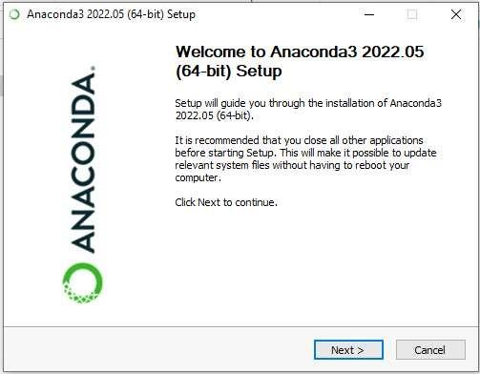

STEP 3: Click I Agree

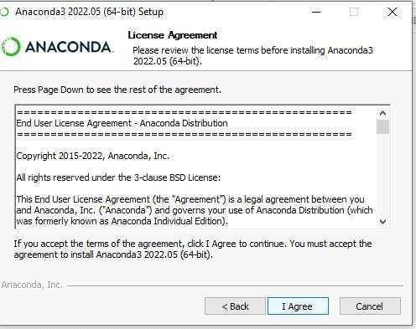

STEP 4: Choose the Installation Location

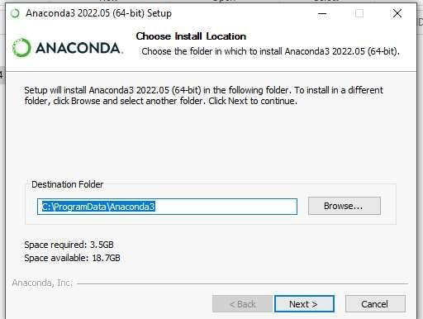

STEP 5: Installing the Requiring packages

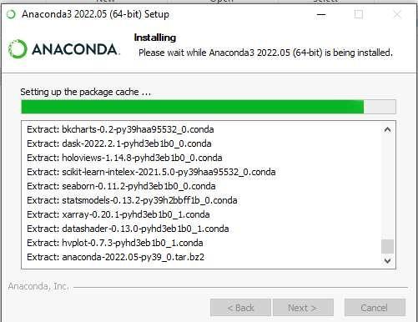

STEP 6: Setting up the base environment

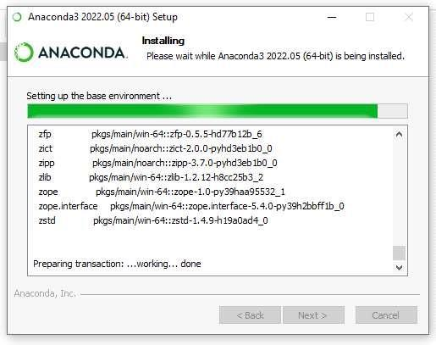

STEP 7: Succesfully Installed and check the Anacoda Navigator working or not

